How to Connect to SQL Server

# Overview

This course requires you to access the Microsoft SQL database server **ist-cs-dw1.ad.syr.edu**. You will need to access it to complete your assignments and class project.

The following document outlines the procedure.

## Requirements

Before you can connect you’ll need the following:

* Your Syracuse University NetID or Password
* SQL Server Developer Utilities: Management Studio and Data Tools.   
  See the 2nd page for options regarding how to access these tools.

## Connection Procedure

Assuming you have access to the developer tools the connection procedure is as follows:

1. Launch **SQL Server Management Studio** from the Windows start menu.
2. From application the menu select **File** 🡪 **Connect Object Explorer**
3. The **Connect To Server dialog** will appear:  
   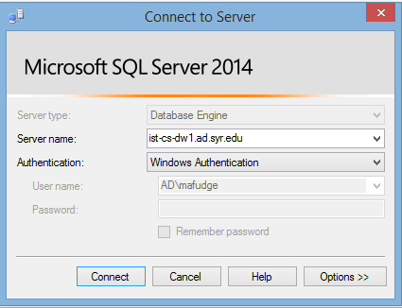  
   For Server Type, select **Database Engine**

For Server name enter: **ist-cs-dw1.ad.syr.edu**For Authentication select: **Windows Authentication**

1. Press the **Connect** button to connect to the server.
2. Under **Object Explorer** you will see several databases.   
   You have **read-only access** to the following databases: ExternalSources, Northwind, Fudgemart_v3, Fudgeflix_v3 (among others)  
   You have **full access**  to these databases: **ist722_*yournetid*_dw** and **ist722_*yournetid*_stage**

## Getting the SQL Server Developer Utilities

The most challenging aspect of connecting to the database server for this course is acquiring the developer utilities. **You have three options.**

1. **Use the iSchool computer labs on the Syracuse University Campus.** All required software for this course is pre-installed in the iSchool computer labs. If it is not practical for you to do this, then you must decide between options 2. Or 3.
   * **Advantage:** Nothing for you to install or configure.
   * **Drawback:** You must be on the Syracuse University campus.
2. **Use the iSchool remote lab.** Remote lab is a website which brokers a remote desktop connection to our computer labs. One you connect with remote lab you have access to all the software found in our campus labs. This is the ideal solution if you have a Mac. To get started go to: <https://remotelab.ischool.syr.edu>
   * **Advantage:** Only install the remote desktop client then you can access from anywhere.
   * **Drawback:** You must have a reliable high-speed internet connection.
3. **Download and install SQL Server Developer Edition**. In this power-user option, you download the SQL Server developer edition to your Windows computer. The software can be obtained for free here: <https://www.microsoft.com/en-cy/sql-server/application-development> Do a full install of the software. After you install the software you must launch the tools using an off-domain short cut as described in this article: <https://answers.syr.edu/display/ischool/Connecting+to+Microsoft+SQL+Server+-+OFF+domain>. This is a workaround because SQL Server requires your NetID and Password, but you are not logged on to the computer with those credentials.
   * **Advantage**: Better performance if you have a poor internet connection.
   * **Drawback:** Complex to setup and configure.

**NOTE:** I highly recommend option 2. Remote lab it requires the least amount of setup on your part and works on multiple platforms (Windows and Mac).